1. Data Preprocessing
Aim:
To perform data preprocessing using Python to clean the dataset by handling missing values, removing duplicate records, and preparing the data for further analysis.
Algorithm:
- Start the program.
- Import the Pandas library.
- Create a dataset using a dictionary.
- Display the original dataset.
- Check for missing values in the dataset.
- Fill the missing values with suitable values.
- Remove duplicate records from the dataset.
- Display the preprocessed dataset.
- Stop the program.
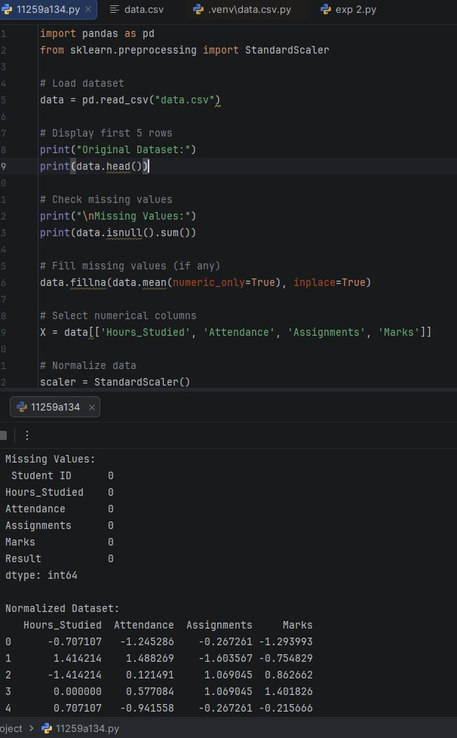
CODE AND OUTPUT:
Result:
Thus, data preprocessing was performed successfully using Python and Pandas by handling missing values and removing duplicate records from the dataset.

